Java OOPs

Task 31:

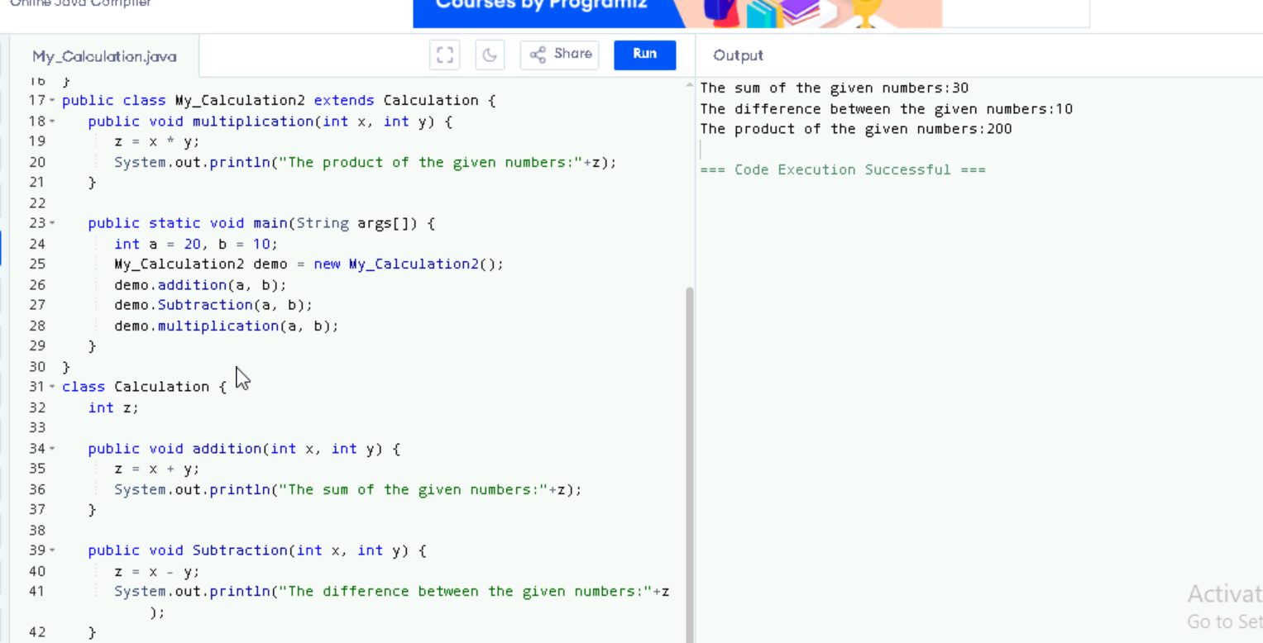

Task 32:

In the above code add a class clock — and try to extend calculation and clock in the my calculation class..   Is it possible ???? give reason.

class clock {

—--

—--

}

class my_calculation extends calculation , clock{  // multiple inheritance

// —---------------------------------- ???????????????????????

}

No, it is not possible.

* Java does not support multiple inheritance with classes (i.e., a class cannot extend more than one class). This is a design decision made by Java to avoid ambiguity and complexity, such as the Diamond Problem.

Task 33:

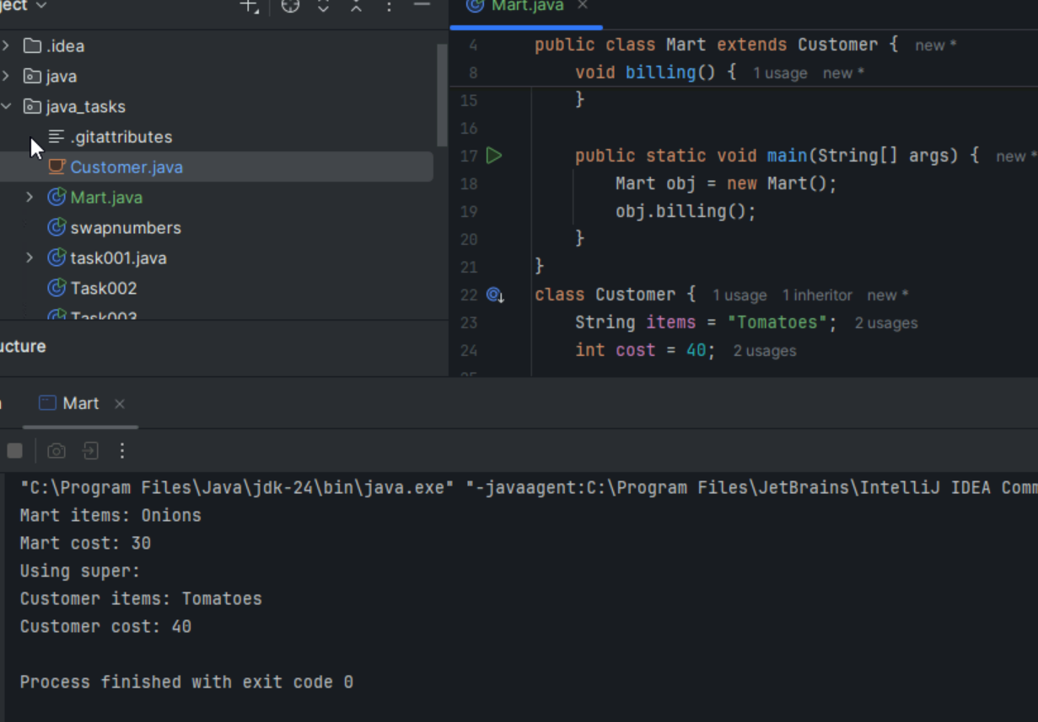

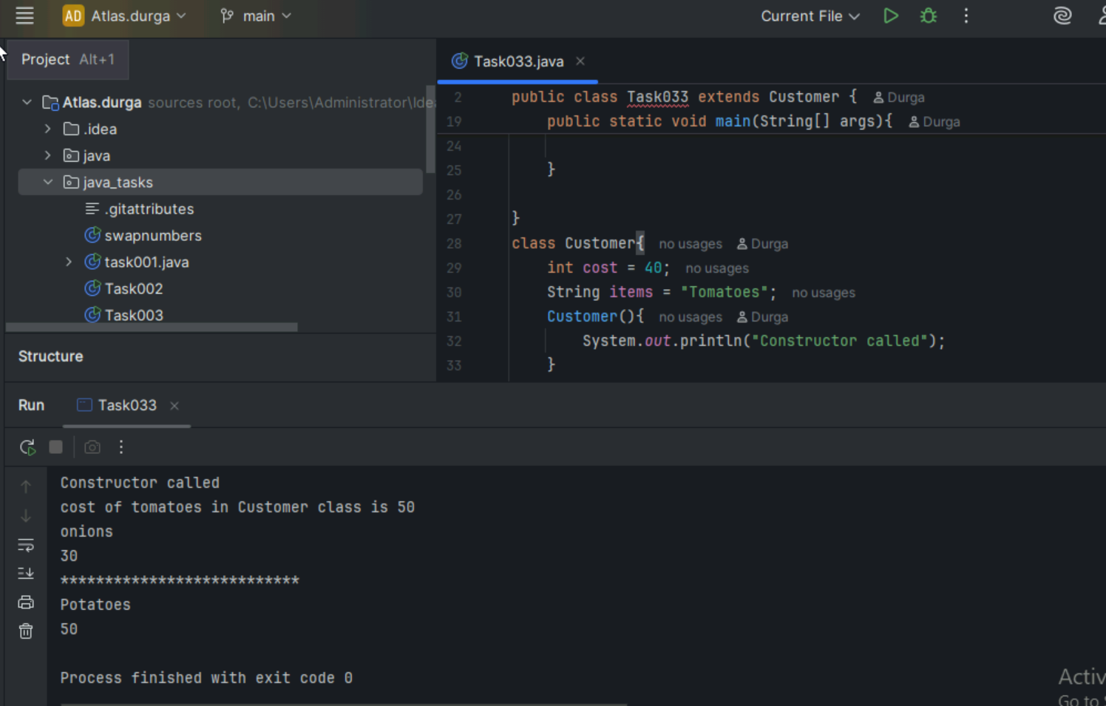

Task 33_01:

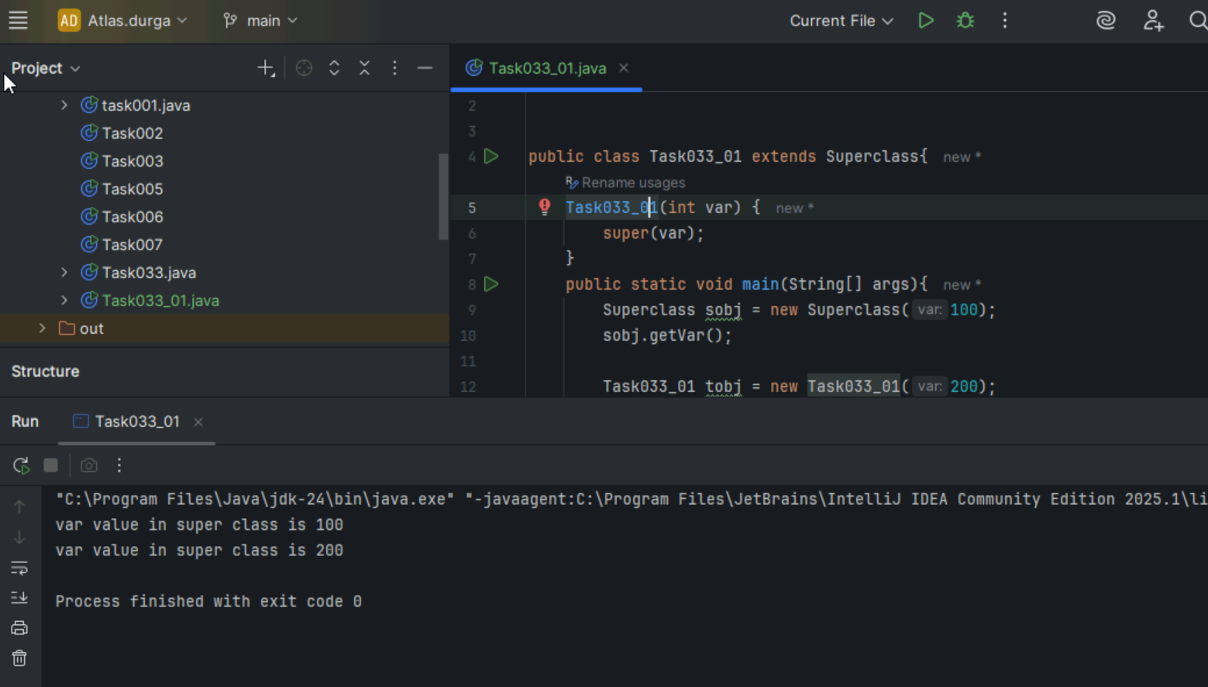

Task 34:

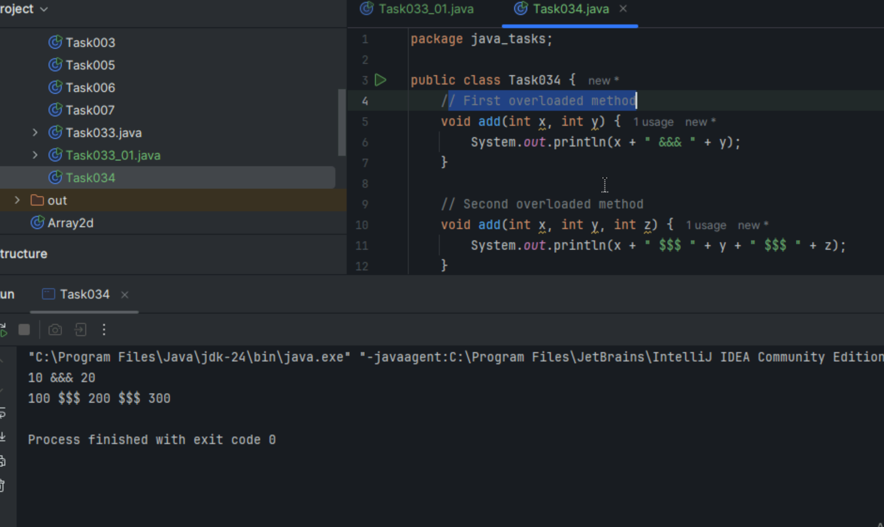

Task 35:

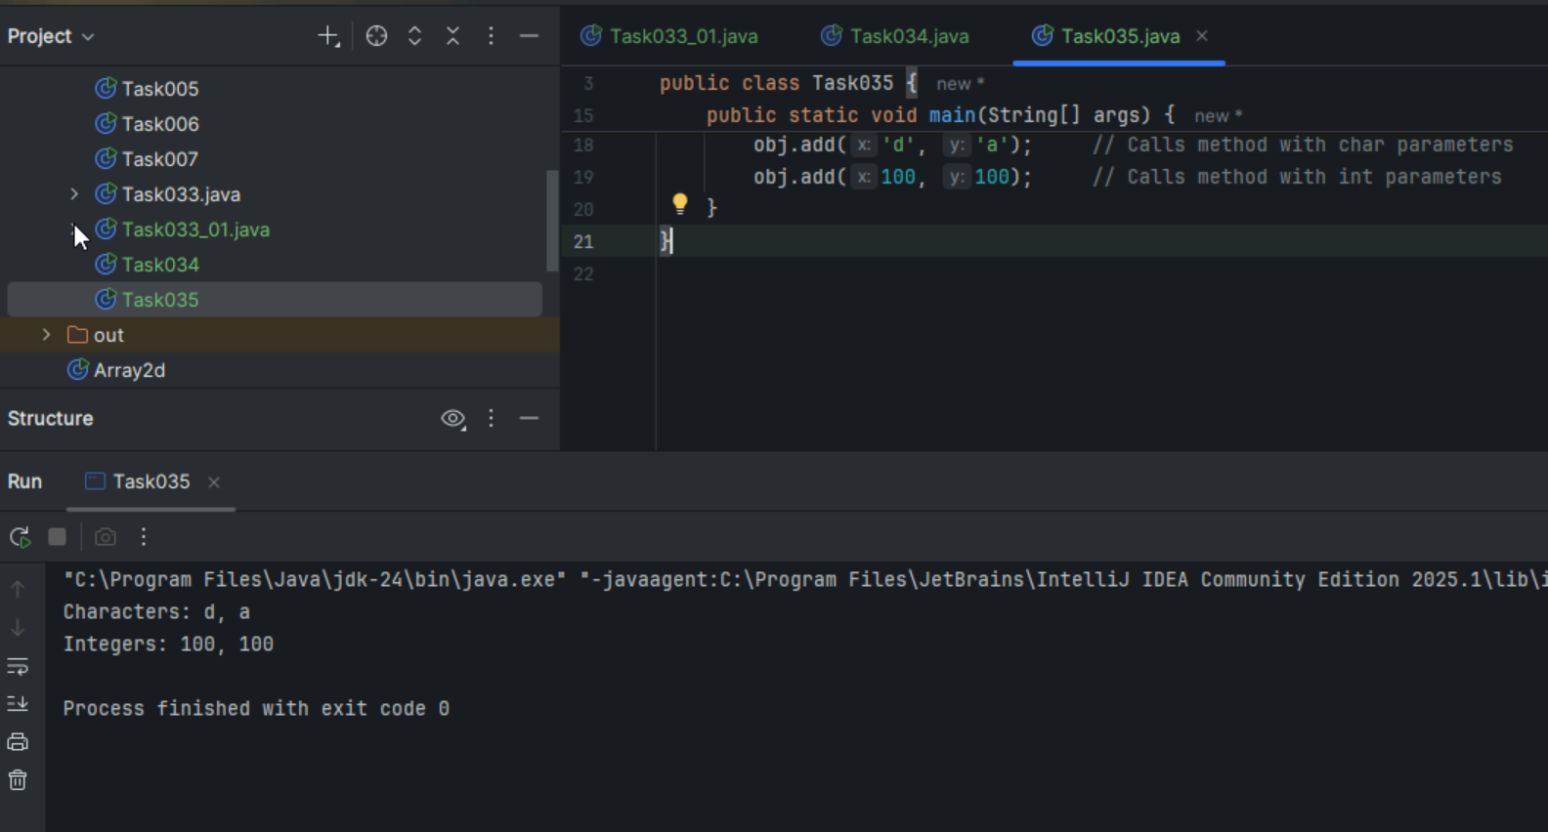

Task 36:

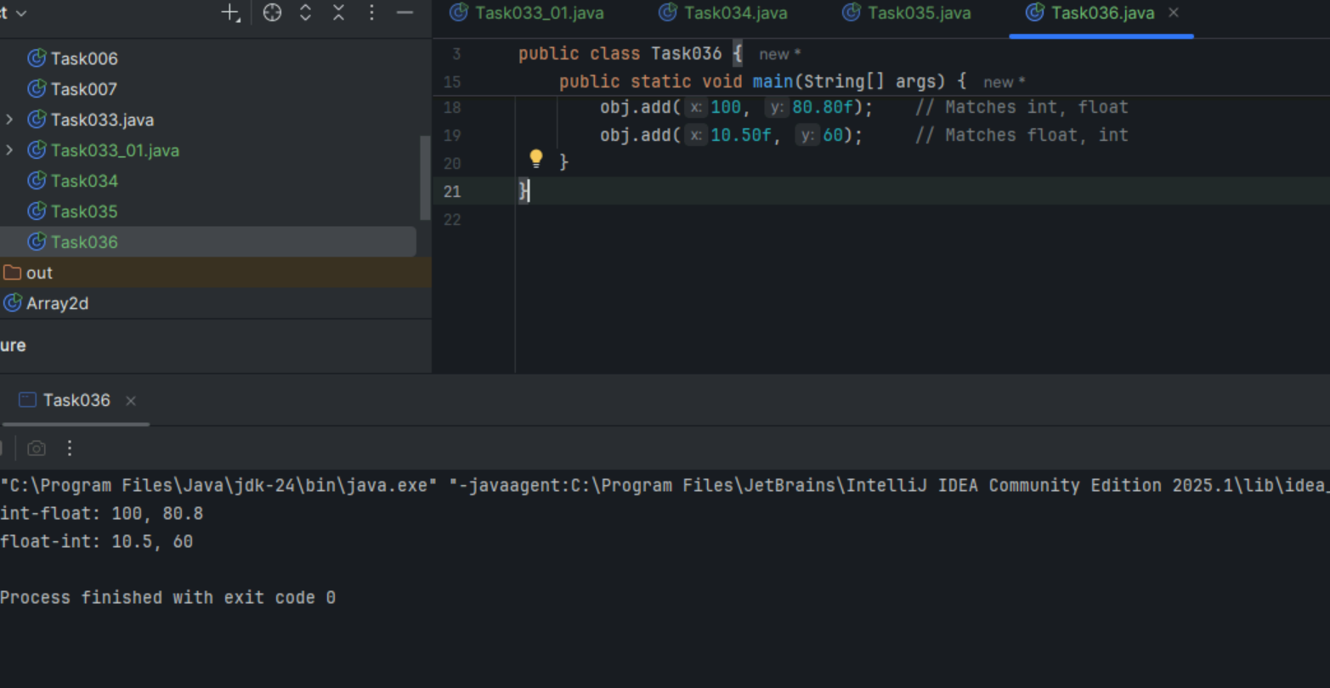

Task 37:

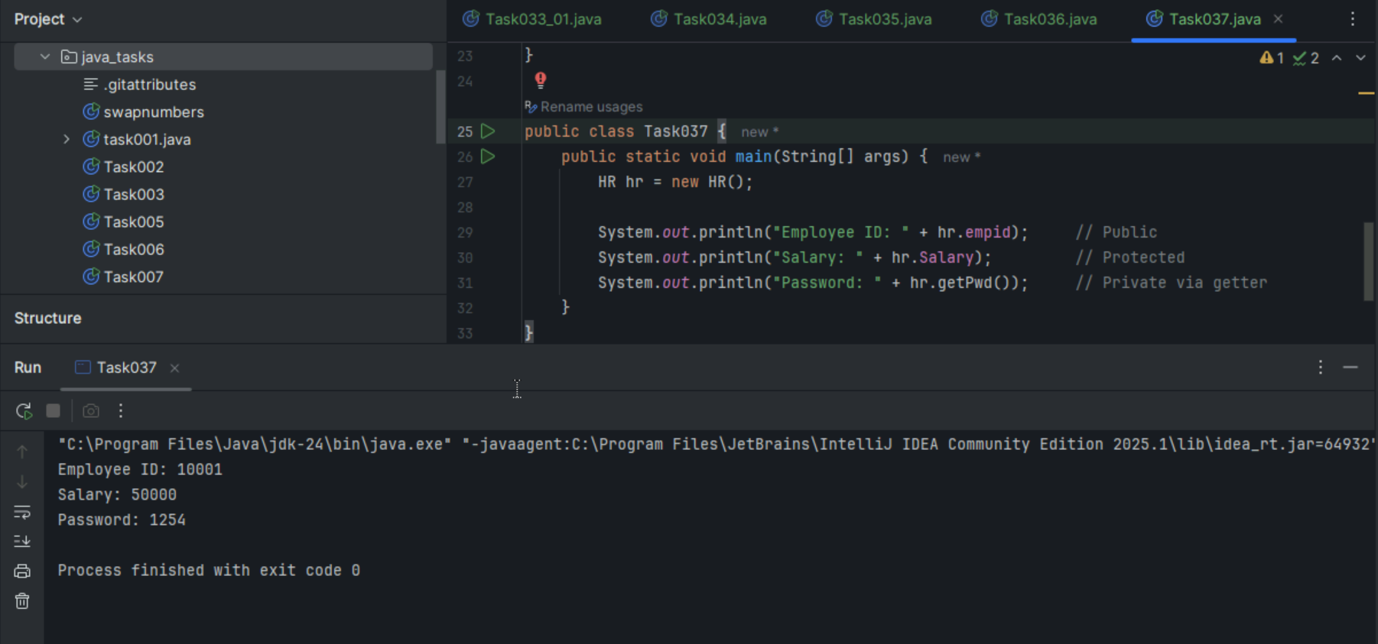

Task 38:

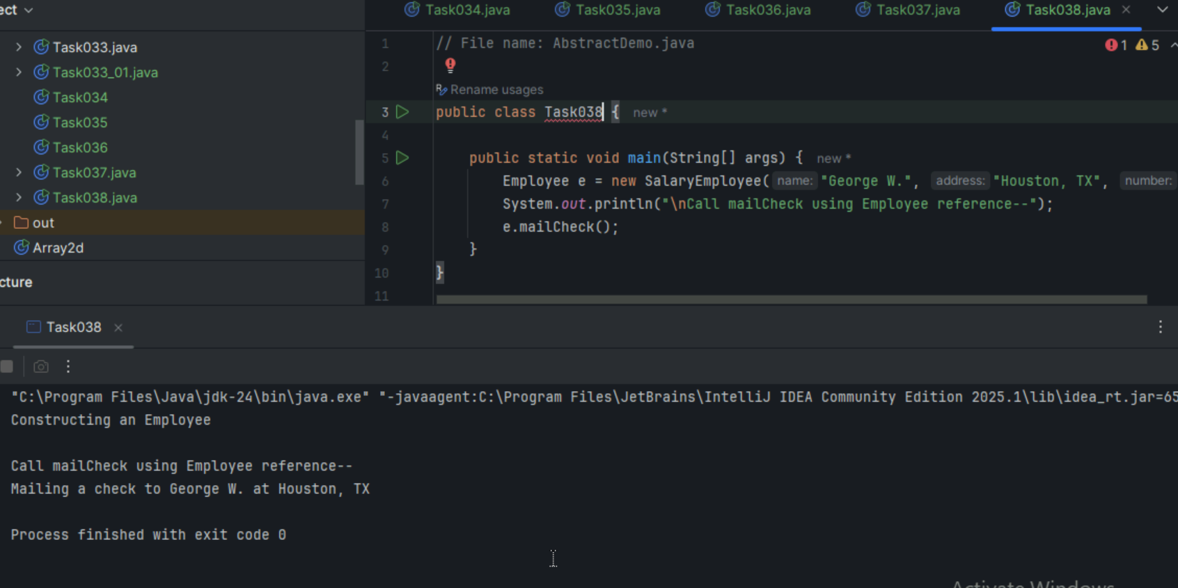

Task 39:

